

**KARATINA UNIVERSITY**

**BACHELOR OF SCIENCE IN COMPUTER SCIENCE**

**SCHOOL OF PURE AND APPLIED SCIENCE**

**DEPARTMENT: COMPUTER SCIENCE AND INFORMATICS**

**COURSE TITLE: COMPUTER SCIENCE PROJECT (II)**

**COURSE CODE: COM 423**

**PROJECT TITLE: ONLINE TEA SALES SYSTEM**

**NAME: KEOYE ISAIAH MORARA**

**REG NO: P101/1246G/16**

**SUBMITTED ON: OCTOBER 16TH 2020**

**This project is submitted in partial fulfilment of requirement for the Karatina University award of BACHELOR OF SCIENCE IN COMPUTER SCIENCE**

## **Dedication**

I dedicate this project to my ever-loving parents and friends who always supported me and stood with me in all situation. Both academically and financially.

I dedicate this project to my all-time supervisor Mr. Zablon O, Birundu for proofreading my work and advising me accordingly all my work that I presented to him.

## **Acknowledgement**

First, I would like to thank God for His protection and the gift of life and good health to this far. All the growly and honor is to Him. Secondly, I would like to thank my proposal supervisor Mr. Zablon Okari for his support, advice and help. Also, I appreciate support from family and friend for their endless love and support in all ways.

## **Declaration**

I hereby declare that this project report is based on my original work except for citations and

quotations which have been duly acknowledged. I also declare that it has not been previously

and concurrently submitted for any other degree or award at Karatina University

Signature: _________________________________ Date: __________________

Name: Keoye Isaiah Morara

**SUPERVISOR**

I the undersigned do hereby certify that this is a true report for the project undertaken by the above-named student under my supervision and that it has been submitted to Karatina University with my approval.

Name: Mr. Zablon Okari.

Signature__________________________________ Date: ______________________.

**TABLE OF CONTENTS**

**Dedication** 1

**Acknowledgement** 2

**Declaration** 3

Abstract 6

CHAPTER ONE: INTRODUCTION 7

**1.1 Introduction** 7

**1.2 Background of study** 7

**1.3 Problem statement** 7

**1.4 Objectives** 8

**1.5 Scope and limitation of the study** 8

**1.6 Justification** 8

**1.7 Ethical considerations / professional impact.** 9

**1.8 Budget and Resources** 9

**1.9 Project schedule** 10

**CHAPTER TWO: LITERATURE REVIEW** 12

**2.1 Introduction** 12

**2.2 Related applications and systems** 12

**Concervis application** 12

**Intuit QuickBooks Online** 13

**Wave Accounting** 13

**Bookkeeper 2015** 14

**Delivrd** 14

CHAPTER THREE: METHODOLOGY 16

**3.1 Introduction** 16

**3.2 Iterative Waterfall model** 16

**3.4 Iterative waterfall stages** 17

**i).** **Requirement gathering and analysis** 17

**ii).** **System design:** 18

**iii).** **System implementation** 18

**iv).** **Integration and testing** 18

**v).** **Deployment:** 18

**3.5 Advantages of iterative waterfall model** 19

**3.6 Disadvantages of iterative waterfall management model** 19

**3.7 Methods of data collection** 20

**3.8 Design tools used** 20

CHAPTER FOUR: SYSTEM ANALYSIS AND REQUIREMENT MODELING 23

**4.1 INTRODUCTION** 23

**4.2 CURRENT SYSTEM** 23

**4.5 REQUIREMENT DEFINITION AND MODELING OF THE NEW SYSTEM** 25

**4.5.1 User requirement** 25

**4.5.3 Software requirements** 25

**4.6 REQUIREMENT SPECIFICATION OF THE PROJECT** 26

**4.7 REQUIREMENT SPECIFICATION** 26

**4.7.1 User Requirement Definition** 26

**4.7.2 Functional Requirement** 27

**4.7.3 Non -Functional Requirement** 27

**4.8 Architecture of the proposed system** 27

CHAPTER FIVE: SYSTEM DESIGN 29

CHAPTER SEVEN: LIMITATIONS, CONCLUSIONS AND RECOMMENDATION 43

**INTRODUCTION** 43

**LIMITATION** 43

**CONCLUSION** 43

**RECCOMENDATION** 44

**References** 45

**Appendix** 46

List of figures

Figure .1: Graphical presentation of iterative waterfall model. 18

Figure 5.6: 1User information database table. 36

# Abstract

This a web-based system that is to be used by tea farmers to keep track of their yearly production as the present system is not conducive for many. the present system entails production of small sale receipts which has a short life span as it fades and is easy to tear if not well kept. Due to bonus payment references that serious producers keep track of their yearlong production and their summary over the years. In this, they will be able to compare the sales and be able to make management decisions by the sales as long as they are concerned.

# CHAPTER ONE: INTRODUCTION

## **1.1 Introduction**

Due to increased technology, there are a lot of systems and application have been developed to reduce the cost of working manually and also to increase productivity. Around the globe, most documents and resources are readily available on the internet and can be accessed from anywhere. This all we appreciate technology and all the dedicated engineers and programmers behind it.

## **1.2 Background of study**

In most Kenyan tea factories, most rely in manual online tea sales in farmer’s records. For instance, to be specific, in Sang’anyi tea factory, there a number of occasions where by both the factory management and farmers alone do much of their work and communication through papers. Production records and payment statements are most done in paper and in case the farmers copy is lost, they don’t have a way of obtaining the lost data. This makes them to lack evidence when they are making complains about lost information or committed errors during service delivery and also makes it difficult to track their general production annually.

For farmers to apply for agrichemical(fertilizer) allocation and distribution to esteemed farmers, the recording is to be done by manually. Mostly there are most cases of product loss by farmers either stolen by unfaithful leaders and mates.

## **1.3 Problem statement**

Due to:

1. Ease loss of data by farmers.
2. Much work done in keeping records.
3. Lack of management tools/system that will fasten decision making

## **1.4 Objectives**

**Main objective**

The main objective of this project is to create a online tea sales site that will avoid use of manual methods of sale management and inventory

**Specific objectives**

1. To study the current systems and find the existing gaps.
2. Gather system’s requirements based on the online tea sales requirement
3. Design the online tea sales system that will help both parties and ease their working and productivity.
4. To develop a online tea sales system that meets the users’ requirements
5. To test the functionality of online tea sales system to determine if there exist any errors
6. Implement the proposed system and deploy it.

## **1.5 Scope and limitation of the study**

This project will increase service delivery, in the course of the proper working and consideration of farmers rights as the rules of the factory. Farmers who need the services will only need any computer with the internet access.

## **1.6 Justification**

The purpose of the project is to increase communication efficiency between the farmers and factory management. Also, it makes much data available on their fingertips as long as they have access to the internet.

Its economical has it reduces space of construction for record storage as more records have to be stored in both the farmers side of view and factory’s side of view. Also, it gives farmers an easy way to access to multiple number of their past records and they can make comparisons and future planning and easy references and business tracking.

## **1.7** Ethical considerations / professional impact.

The online tea sales system keeps in mind the rights and privacy of both parties before using the system. The security on the files and documents stored in the system from external interference by other computer users is well taken care of. The system considers all management personnel as capable of using the system for handling and scheduling except those who are blind, mentally disabled and those who don’t know how to read and computer illiterate. The system has no physical dangers to the users except where they willingly want to suffer eye strain by using high brightness due to failure of the hardware drivers or in uncontrollable circumstances is only where the system has affected the user but through his/her own consequence.

## **1.8 Budget and Resources**

#### **1.8.1** **Resources**

Computer/laptop

XAMPP/WAMPP (any database platform supporting MySQL)

Editor

Use of CSS knowledge

Use of JavaScript knowledge

Use of PHP knowledge

#### **1.8.2** **Budget**

|  |  |
| --- | --- |
| **Resource** | **Price** |
| Laptop | Sh. 30,000.00 |
| Domain name | Sh. 1500.00 |
| PHP knowledge | Free |
| Android studio knowledge | Free |
| JAVA | Free |
| SDK/JDK | Free |
| XAMPP | Free |
| Editor | free |
| **TOTAL** | **31500.00** |

Table 1:Project cost

## **1.9 Project schedule**

This project will take an estimated period of 14 weeks from as represented by the following Gantt chart. Every activity in development process will be documented as represented in the following figure.

|  |  |  |  |  |  |  |  |  |  |  |  |  |  |  |
| --- | --- | --- | --- | --- | --- | --- | --- | --- | --- | --- | --- | --- | --- | --- |
| **Activity** | **Week** | | | | | | | | | | | | | |
|  | 1 | 2 | 3 |  |  |  |  |  |  |  |  |  |  |  |
| Project proposal |  |  |  |  |  |  |  |  |  |  |  |  |  |  |
| Project description |  |  |  |  |  |  |  |  |  |  |  |  |  |  |
| Project proposal |  |  |  |  |  |  |  |  |  |  |  |  |  |  |
| Literature review |  |  |  |  |  |  |  |  |  |  |  |  |  |  |
| Function specialization |  |  |  |  |  |  |  |  |  |  |  |  |  |  |
| Software design |  |  |  |  |  |  |  |  |  |  |  |  |  |  |
| Coding |  |  |  |  |  |  |  |  |  |  |  |  |  |  |
| Software testing |  |  |  |  |  |  |  |  |  |  |  |  |  |  |
| Implementation |  |  |  |  |  |  |  |  |  |  |  |  |  |  |
| Documentation |  |  |  |  |  |  |  |  |  |  |  |  |  |  |

Table 2: Project schedule

**CHAPTER TWO: LITERATURE REVIEW**

## **2.1 Introduction**

In this chapter will elaborate the literature review concerning the project citing the secondary sources of similar systems of digital online tea sales and skills exchange between farmers and specialist as a result of advanced technology. I appreciate tireless individual who are working day and night to make our day to day tasks and life easier and increase software productivity. Therefore, from my research study, there are available works that have slightly similar functionalities as this system but have some weakness. Analysis of tools to be used in the development of the application will also be covered in this chapter.

## **2.2 Related applications and systems**

### **Concervis application**

This is a farm management application that was developed in Australia that is useful in farm production. Was created to help farmers manage their farm. Concervis delivers the insight to manage complex agricultural operations, using enterprise software and personalization to run your business from planning to harvest. Concervis has two platforms, one for permanent crops (such as fruit trees) and one for Row/annual cropping rotations. Its main features are Planning and budgeting.

1. Purchasing and inventory
2. Production and work orders
3. Harvest and distribution
4. Configured to meet your needs
5. Onsite training available
6. Dedicated support
7. Reporting

Even though the application equips farmers with skills and helps them to be able to keep inventory and purchasing of the related inputs for increased production, it doesn’t include farmers who take their products to a specific factory. Either does it help in keeping farm sales and expenditure records. Also, it charges all members who have been registered to use the services.

### **Intuit QuickBooks Online**

Intuit QuickBooks Online is widely rated as one of the best overall accounting and record-keeping software programs available. This software allows you to input your data, and it automatically performs accounting tasks. The program also allows you to integrate business solutions you may currently be using, including Microsoft Excel spreadsheets. Among other things, with QuickBooks, you can keep track of daily expenses and transactions, pay bills and employees, send invoices and sync data across all financial accounts. This software can offer the most basic features or be customized with advanced functions to fit the needs of your business. It is entirely cloud-based so you have access to the software and all data from any Internet-connected device.

Despite of its worthiness, the application majors more in accounting related function that are not much needed by most small scale and peasant farmers. Its more convenient to bigger business. Also, it does not support sharing of data among multiple users, it’s a single user software.

### **Wave Accounting**

One of the most attractive qualities of Wave Accounting is it is completely free. Wave Accounting also uses cloud computing so it is suitable for your business if you are constantly on the move and need access to your data from any location. This software does not have all of the same features as paid programs, but it offers the option for payroll and customer service with an additional fee, which depends on what and how many additional features you add. Wave Accounting does have the core capabilities of tracking expenses, creating financial reports and sending invoices. Ultimately, this software is best suited to startups or businesses that remain small, mainly those with 10 or fewer employees. It is excellent for freelance workers and entrepreneurs.

Wave account’s limitation is that it needs a small number of users (less or equal to 10). This is also accounting oriented. And its paid for when you want to add some features. Its functionalities are more than what small scale farmers need.

### **B****ookkeeper 2015**

Bookkeeper 2015 is a good choice for small business if you need an easy program that sets up quickly and allows you to easily manage records. This software allows you to create checks and pay bills, send invoices to customers, and track sales and all expenses. Among a variety of other features, Bookkeeper also allows you to process credit card payments and automatically prepare taxes utilizing all necessary inputted data. New features added to the 2015 version of the software give you support for asset disposal and multiple depreciation methods. The price for this comprehensive software is just under $40 as of December 2015.

Bookkeeper 2015 is software that is mostly used by business firms and is for a single user. It works well in business-oriented firms. Therefore, it doesn’t allow data sharing.

### **Delivrd**

Delivrd is a cloud-based inventory management and order fulfillment solution that just launched its first official release at the end of 2016.

The company offers two plans—free, and $50 per month. The free plan covers one location and 25 SKUs and is a great option for businesses that have a narrow focus, such as online retailers and specialty product retailers.

If you’re using WooCommerce or Shopify, Delivrd can integrate directly with them, making life a whole lot easier on the back end. If you use another eCommerce platform, you’ll have to work through some manual data transfer to make it all work. Delivrd also supports barcoding, pick and pack, and some financial reporting. At the paid level, you get access to more locations and products, as well as getting some PO and sales management tools.

Delivrd is an inventory keeping software for a business firm. It’s a good software that since is a cloud based and it assures user data security. There is minimal data loss and data is accessed from whichever place. It’s a perfect software for business that major in selling and buying of goods.

**Summary**

From all the mentioned above software applications they are all online tea sales oriented but they major in accounting that’s more above peasant farmers, they all favor business firms that sell and buy goods and services. There isn’t even a single software or system that supports more than 1000 users to share data and access it from anywhere. A good number of them are also paid for the user to be able to use them and other added features.Therefore, they are not convenient for small scale farmers and peasants. They don’t allow sharing of records. Therefore, the system that I will implement will have this as an added functionality and it will be free of charge. All that is need is internet access and get all your production records and payment receipts.

# CHAPTER THREE: METHODOLOGY

### **3.1 Introduction**

In this chapter, a development methodology is proposed to be used to develop the whole system requirement analysis to maintenance. Each and every stage of activity, the

### **3.2 Iterative Waterfall model**

Iterative waterfall model can be thought of as incorporating the necessary changes to the classical waterfall model (first software development lifecycle model) to make it usable in practical software development projects. It is almost same as the classical waterfall model except some changes are made to increase the efficiency of the software development. The iterative waterfall model provides feedback paths from every phase to its preceding phases, which is the main difference from the classical waterfall model.

Requirement Analysis

System Design

Implementation

Testing

Deployment

Maintenance

Figure 0.1: Graphical presentation of iterative waterfall model.

When errors are detected at some later phase, these feedback paths allow correcting errors committed by programmers during some phase. The feedback paths allow the phase to be reworked in which errors are committed and these changes are reflected in the later phases.   
It is good to detect errors in the same phase in which they are committed. It reduces the effort and time required to correct the errors.

The model has the following phases

1. Requirement gathering send processing
2. System design
3. System implementation(coding).
4. System integration and testing
5. System deployment
6. System maintenance

**3. 3 When to use iterative waterfall method**

1. Requirements of the complete system are clearly defined and understood.
2. When the project is big.
3. Major requirements must be defined; however, some details can evolve with time.

## **3.4 Iterative waterfall stages**

* 1. **Requirement gathering and analysis**

The process of establishing what services are required and the constraints on the system’s operation and development. It is now called Requirements Engineering process and consists of the following phases.

a) Feasibility study – done to determine is the proposed system will be cost- effective from a business point of view and can be developed given existing budgetary constraints.

b) Requirements elicitation and analysis - used to deliver the system requirements.

c) Requirements specification - specifying the system requirements

d) Requirements validation– checks the requirements for realism, consistency and completeness.

* 1. **System design:**

Software design is a process to transform user requirements into some suitable form, which helps the programmer in software coding and implementation.

For assessing user requirements, an SRS (Software Requirement Specification) document is created whereas for coding and implementation, there is a need of more specific and detailed requirements in software terms. The output of this process can directly be used into implementation in programming languages.

Software design is the first step in SDLC (Software Design Life Cycle), which moves the concentration from problem domain to solution domain. It tries to specify how to fulfill the requirements mentioned in SRS.

* 1. **System implementation**

At this stage, the designed and written architecture and requirement will be made to define the working of the system. With inputs from system design, the system will first be developed in small programs called units, which are integrated in the next phase. Each unit is developed and tested for its functionality which is referred to as Unit Testing.

### **Integration and testing**

All the units developed in the implementation phase are integrated into a system after testing of each unit. The software designed, needs to go through constant software testing to find out if there are any flaw or errors. Testing is done so that the client does not face any problem during the installation of the software

### **Deployment:**

Once the functional and non-functional testing is done, the product. Will be deployed in the customer environment or released into the market. This is where the product will be put to work into the users’ desires.

* 1. **Maintenance**

This step occurs after installation, and involves making modifications to the system or an individual component to alter attributes or improve performance. These modifications arise either due to change requests initiated by the customer, or defects uncovered during live use of the system. Client is provided with regular maintenance and support for the developed software.

### **3.5 Advantages of iterative waterfall model**

* **Simple:** Iterative waterfall model is very simple to understand and use. That’s why it is one of the most widely used software development models.
* In iterative model we can only create a high-level design of the application before we actually begin to build the product and define the design solution for the entire product. Later on, we can design and built a skeleton version of that, and then evolved the design based on what had been built.
* In iterative model we are building and improving the product step by step. Hence, we can track the defects at early stages. This avoids the downward flow of the defects.
* In iterative model we can get the reliable user feedback. When presenting sketches and blueprints of the product to users for their feedback, we are effectively asking them to imagine how the product will work.
* In iterative model less time is spent on documenting and more time is given for designing.

### **3.6 Disadvantages of iterative waterfall management model**

* **Difficult to incorporate change requests:** The major drawback of the iterative waterfall model is that all the requirements must be clearly stated before starting of the development phase. Customer may change requirements after some time but the iterative waterfall model does not leave any scope to incorporate change requests that are made after development phase starts.
* **Incremental delivery not supported:** In the iterative waterfall model, the full software is completely developed and tested before delivery to the customer. There is no scope for any intermediate delivery. So, customers have to wait long for getting the software.
* **Overlapping of phases not supported:** Iterative waterfall model assumes that one phase can start after completion of the previous phase, but in real projects, phases may overlap to reduce the effort and time needed to complete the project.
* **Risk handling not supported:** Projects may suffer from various types of risks. But Iterative waterfall model has no mechanism for risk handling.
* **Limited customer interactions:** Customer interaction occurs at the start of the project at the time of requirement gathering and at project completion at the time of software delivery. These fewer interactions with the customers may lead to many problems as the finally developed software may differ from the customers’ actual requirements.

## **3.7 Methods of data collection**

**Direct observation**

This a method used to get firsthand information directly from the field. It requires the researcher to go to the field directly and extract data from the audience or study objects and record as it is. This can be reinforced by interviews and surveys using questionnaires. Then the obtained data is analyzed and processed for final use.

**Interviews**

Is a technique used by a researcher to get firsthand information directly from the source. It requires the researcher to ask question directly to respondent. It can be done face to face or through phone call.

## **3.8 Design tools used**

JavaScript (JS)

Is high level, interpreted programming language (is a scripting language). Is a language that’s which is also characterized as dynamic, weakly-typed, prototype based and multi paradigm. Alongside HTML and CSS, JavaScript is among the three core technologies of world wide web. It runs on client side of the web. It will be used to design/program on how the web pages behave on the occurrence of an event.

CSS

Is abbreviation of Cascading Style Sheets. Cascading style sheets are used to format the layout of Web pages. They will be used to define text styles, table sizes, and other aspects of Web pages that previously could only be defined in a page's HTML.CSS will help me as a developer to create a uniform look across several pages of a Web site. Instead of defining the style of each table and each block of text within a page's HTML, commonly used styles need to be defined only once in a CSS document. Once the style is defined in cascading style sheet, it can be used by any page that references the CSS file that will be created.CSS makes it easy to change styles across several pages at once

AJAX

AJAX is an acronym that stands for Asynchronous JavaScript and XML, and it describes a set of development techniques used for building websites and web applications. AJAX’s core function is to update web content asynchronously (the “A” of AJAX), meaning a user’s web browser doesn’t need to reload an entire web page when only a small portion of content on the page needs to change. AJAX is commonly used to update features like status and notification bars, online forms, comments sections, and surveys and polls.

HTML

Stands for "Hypertext Markup Language." HTML is the language that will be used to create webpages. "Hypertext" refers to the hyperlinks that an HTML page may contain. "Markup language" refers to the way tags are used to define the page layout and elements within the page. However, even dynamic pages will be formatted using HTML. Therefore, scripting languages will often generate the HTML that will be sent to users’ web browser.

PHP

Stands for "Hypertext Preprocessor." PHP is an HTML-embedded Web scripting language. When a PHP page is accessed, the PHP code is read or "parsed" by the server the page resides on. The output from the PHP functions on the page are typically returned as HTML code, which can be read by the browser. Because the PHP code is transformed into HTML before the page is loaded, users cannot view the PHP code on a page. This make PHP pages secure enough to access databases and other secure information. The goal of the language is to allow Web developers to write dynamically generated pages quickly and easily. PHP is also great for creating database-driven Web sites. This the language that will be used to access the record from the database.

SQLITE

This is a database that is used to store data in desktop applications,hosts and makes data to be easily manipulated and more portable than other DBMSs. This is more suitable to make the database more secure.

# CHAPTER FOUR: SYSTEM ANALYSIS AND REQUIREMENT MODELING

## **4.1 INTRODUCTION**

System analysis involves the study of the procedures to enable identification of goals towards creating efficient systems. This section breaks the system into components so as to enable a clear study of their integration toward achieving the goals. Requirement analysis focuses on the needs and conditions to be met by the development of the system. It measures the success or failure of the system. The requirements should be documented, measurable, actionable and user are sensitive

### **4.2 CURRENT SYSTEM**

Currently there are a number of applications that have been made by dedicated programmers, organizations and companies thanks to them. Even though some are availed as free applications, they are mostly fixed to a given field of use. Like Business sales record book, it is usually impossible to change it to accommodate farm related sales record. Most farmers still use the manual outdated methods of keeping track of their sales making the process tiresome and cumbers. In case of immediate sales retrieval attempts, it is hard but the same can be done in just few click that entail that require on to log into the application

**4.3 GAPS IN THE CURRENT SYSTEM**

The present applications work for only business that mostly require finances i.e. it focuses mostly on the product inflow and outflow as well as cash that is flowing to the business, invoices, and profit and loss management. Generally, the present programs are based on accounting and financial management. And others are purely in inventory related field.

The most of present program applications only hold dater for only one user. This makes other users also to have their personal computers to access their past data and product sales. It is also able to support sales to different companies.

**4.4 DATA FLOW DIAGRAMS IN THE SALES RECORD APPLICATION**

Admin login

Make transactions

Report generation

Data integrity

Admin Actions

* Add sale
* Remove
* update

Figure 4.1 Current application control

The above diagram is the chart of the present sale applications that the present application program takes. The data integrity module handles the incoming and outgoing products while the transaction deals only with monetary issues.

Administrator

## **4.5 REQUIREMENT DEFINITION AND MODELING OF THE NEW SYSTEM**

During the system study phase, requirements of sales management system were categorized into user requirements, system and hardware requirements.

### **4.5.1 User requirement**

First hand data was collected and it was realized that sales that have been made by primary producers (farmers) usually are not recorded and incase of loss of the sale receipts, it becomes a challenge to track the sales maybe after a month. The users described some of the basic requirements of the system this includes lookup of buyers, add/ update of sales in the database, and delete some records from records and generation of pdf as physical evidence.

**4.5.2 Hardware Requirements**

Hardware requirements for running this project are as follows:

|  |  |
| --- | --- |
| Central Processing Unit | Intel quad core and above |
| Random Access Memory (RAM) | 1GB |
| Hard disk space | 200GB |
| Processor | 1.6GHZ |

### **4.5.3 Software requirements**

Software required to make working of product is: -

Windows OS (supports windows 10, windows 8.1, windows 8, windows 7, windows 2000)

Chromephp desktop will be the interface designer.

PhpliteAdmin to create and manipulate database

Phpliteadmin advantages

* Security
* On- demand scalability
* High performance
* Complete workflow control
* Highly flexible

## **4.6 REQUIREMENT SPECIFICATION OF THE PROJECT**

The purpose of requirement definition and specification is to write the functional and non-functional user or system requirements that represent the characteristics of Sales management system.

They include:

• The system should have a database which is user friendly and robust.

• The system should be secure. Several techniques of security enhancement.

• Access speed to the system, data access and update should be immediate.

• The system should use off-the-shelf components and the cost should be reasonable.

• The system should be always available for ready use as long as it is installed.

### **4.7 REQUIREMENT SPECIFICATION**

After analyzing the data observed, a number of requirements were formulated namely user requirement, system requirement; that is hardware and software attributes. These were grouped as user, functional, non-functional and systems requirements.

### **4.7.1 User Requirement Definition**

The user requirement for this system is to make the system fast, flexible, less prone to error, reduce expenses of following up sales and references and calculations.

* Easy calculations of performance of the sales as the user specifies sale rates.
* The system should be more secure for management customer records and more reliable to work at any conditions.
* The user should find it easy to perform basic functions.

### **4.7.2 Functional Requirement**

The following is the desired functionality of the new system.

* The system should accept submissions in form of new sales
* The system should analyze of financial productions expected excluding farm inputs
* The system should authenticate the users of the system.
* The system should generation of reports on request.
* The system should only allow the administrator to delete records in the database.

### **4.7.3 Non -Functional Requirement**

* The system should verify and validate all user input and users must be notified in case of errors detected in the course of using the system.
* The system should allow room for expansion.
* A system should have a high performance and reliability level.

### **4.8 Architecture of the proposed system**

Database

Report generation

User reports

Sales

Data integrity

Data input

Forms

**Graphical user interface**

- User authentication

- Sales management

- User management

**Front End**

**Backend**

**Process**

**Database**

Add user

Change password

Update user

Remove user

Search

Sale calculation

Email

Add sale

Update sale

Clear sale

Data management

User management

Management tools

Dashboard

Authentic?

Sign up

Login

Having account?

No

Yes

No

Database interaction

Figure 4.3 Activity Diagram

# CHAPTER FIVE: SYSTEM DESIGN

**Introduction**

This chapter describes how I designed the system as by the requirements found in the previous chapter i.e. requirement specification.

**System design**

A system design is a model of a real-world system that has many participating entities and relationships. This design is used in different ways. It acts as a basis for detailed implementation; it serves as a communication medium between the designers of subsystems; it provides information to system maintainers about original intentions of the system designer.

In this work, a function – oriented design was chosen. A function- oriented design relies on decomposing the system into a set of interacting functions with a centralized system state shared by these functions. Database design is the process of producing a detailed data model of a database. This logical data model contains all the needed logical and physical design choices and physical storage parameters needed to generate a design in a data definition language which can be used to create a database. A fully attributed data model contains detailed attributes for each entity.

**System interface designs**

The interfaces of the system were created using sublime text application and SQLite Expert Professional version 5.3.

**Log in interface design**

The system is ought to have a log in interface to enhance the site integrity, authentication and all other security measures are it hold information that need to be altered by unnecessary people or users of the user device. The user log-in interface is as shown below.

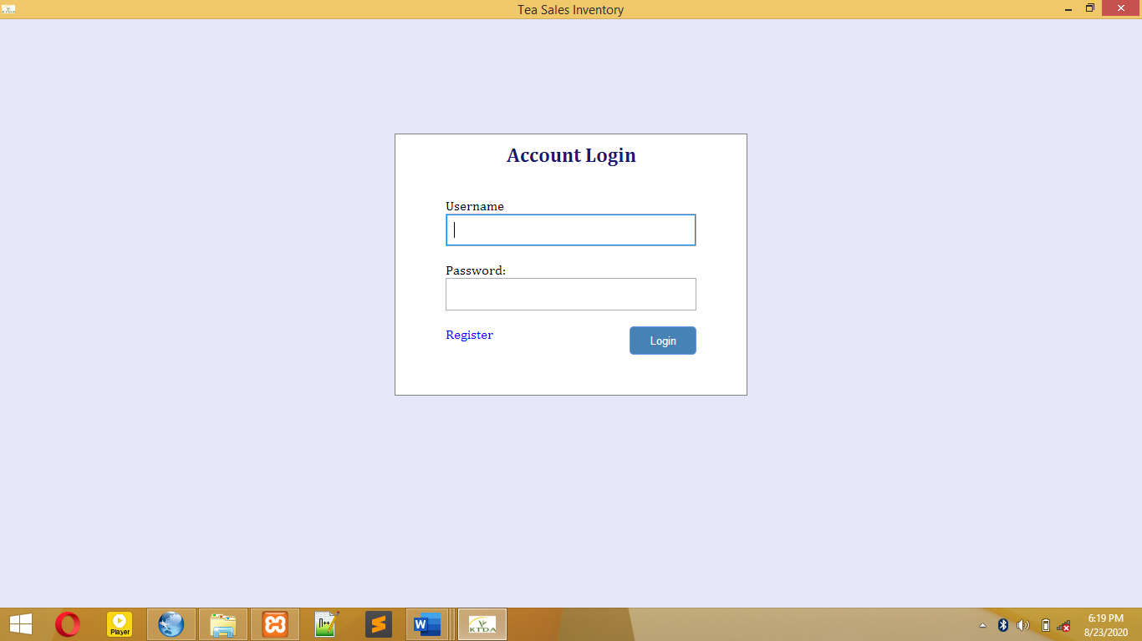

Figure 5.1 System log in interface

**Signup interface design**

The signup interface is useful in registering the seller/ user of the system. This system supports only one user. During addition of new sales, you are required to input the user code to avoid addition of fake users. To avoid this, the user has to register.

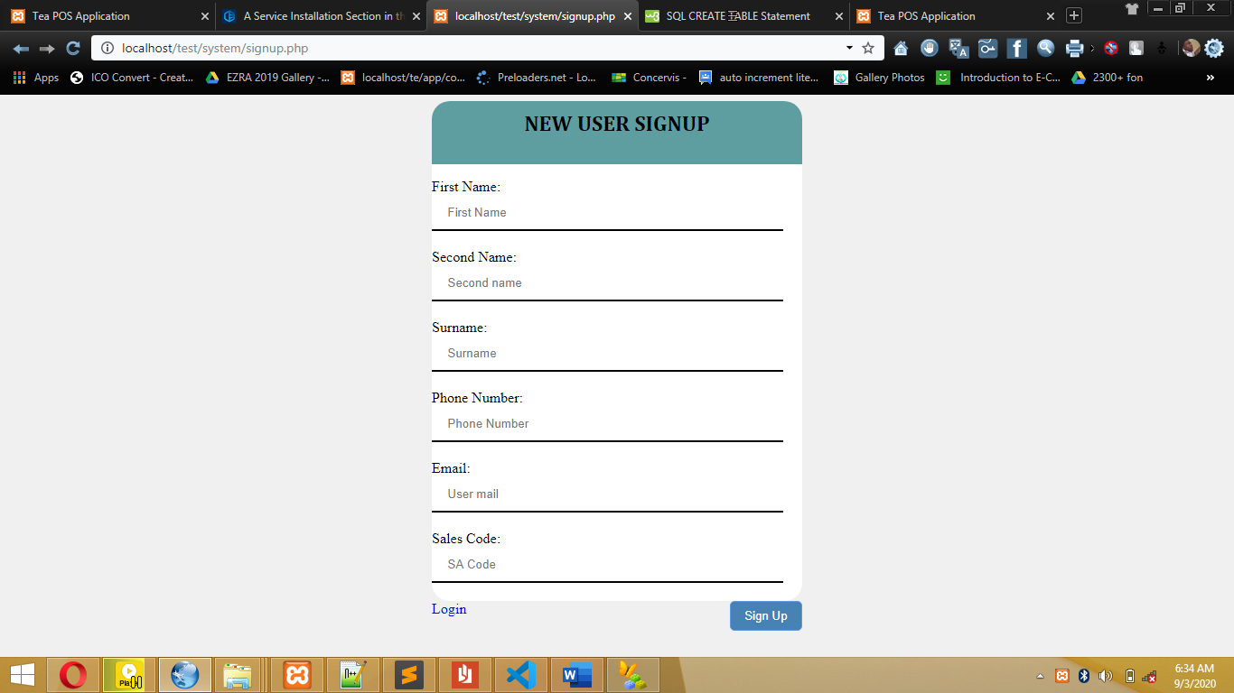

Figure5. 2: User signup interface.

**Record addition interface design**

This is a module that allows the users to add new sales to maintain the integrity of the records and ease the tiresomeness of paperwork as the sale receipts are issued.

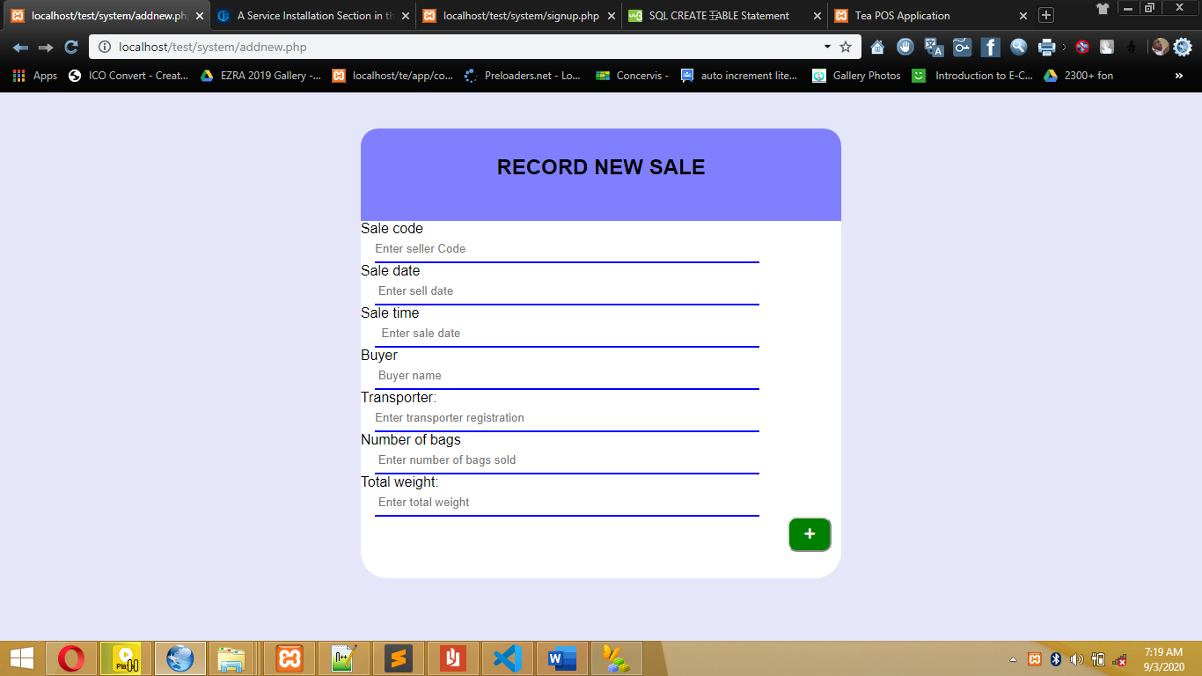

Figure 5.3 New sale addition interface

**Sales interface design**

This is the interface that allows the user to see the annual sales in graphical form and analyze them accordingly. The interface uses bootstrap and Sb admin graph library to do graphs and to make the summary of the sales.

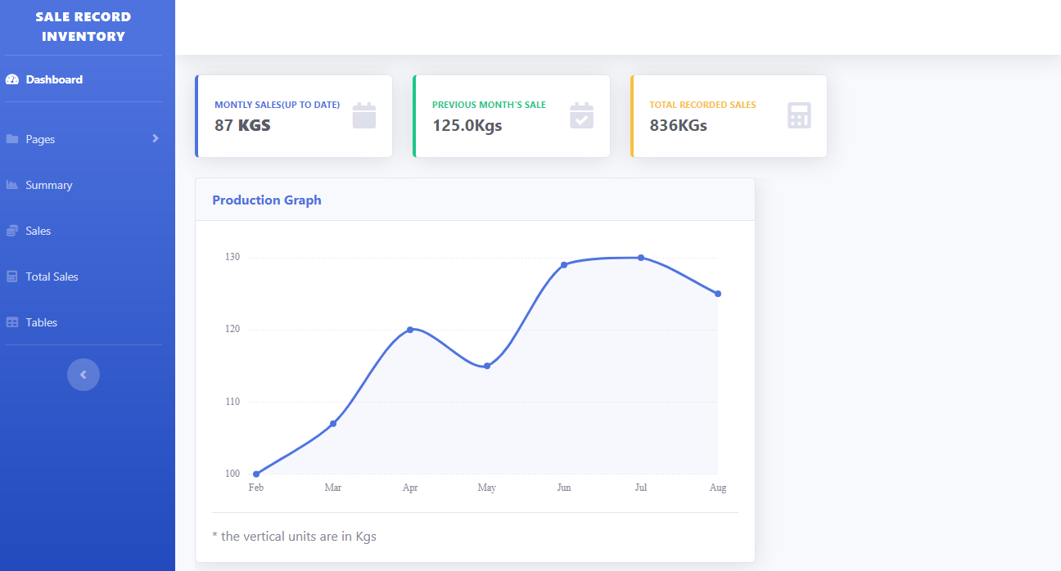Figure 5.4: Summary interface

**Database interface**

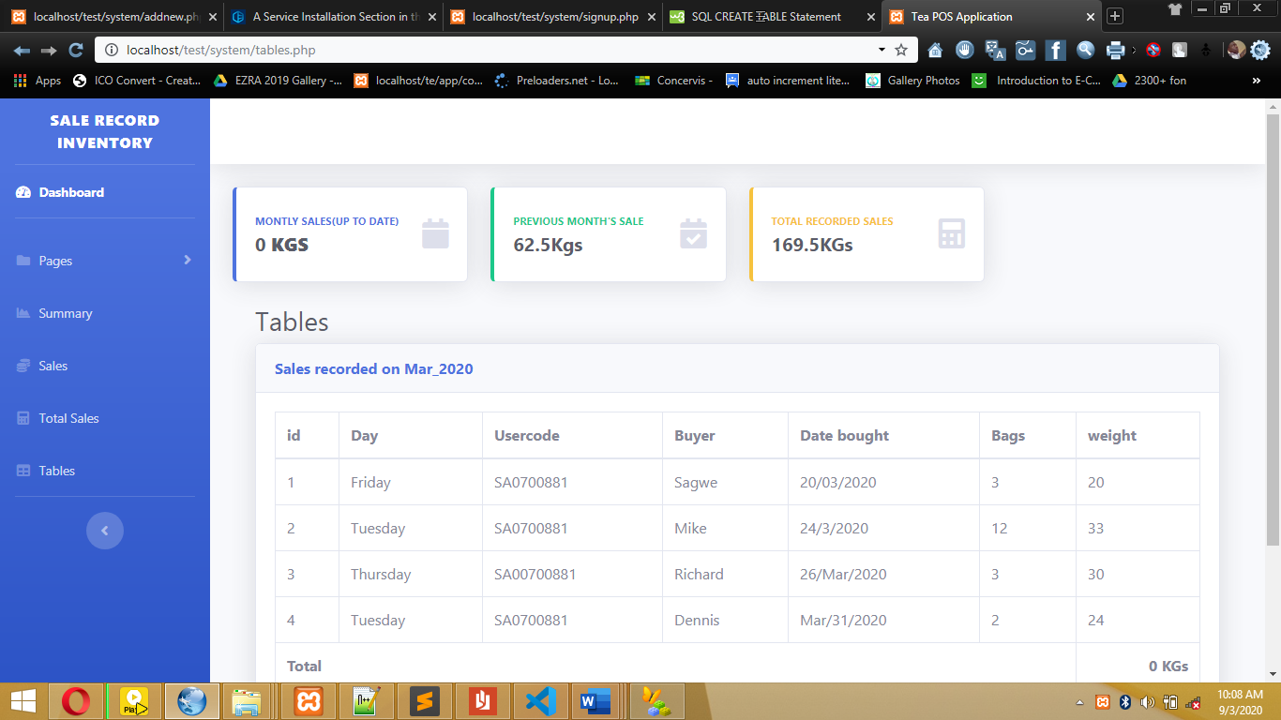 Figure 5.5 (a): Data table interface

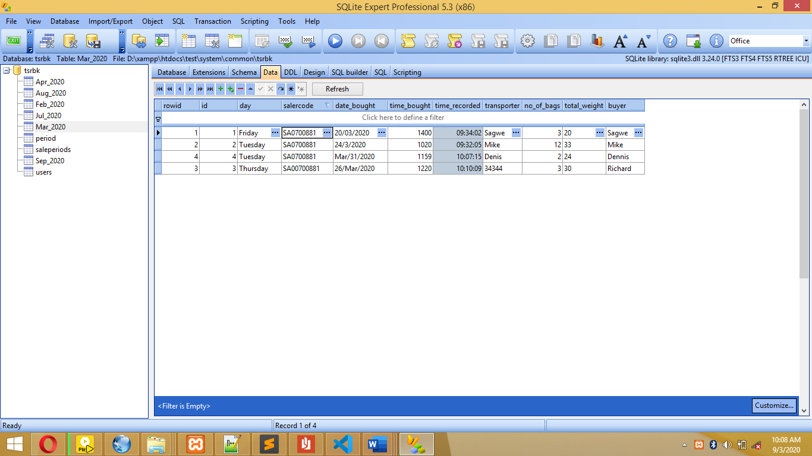

Figure 5.5 (b): Database table view

The figure 5.5(a) above show the summarized database interface for the user in form of a table where it is much easier to read and understand. The part(b) figure shows the image of the SQLite Expert Professional application showing the view of the database as it is created in the database system.

A relational database design was used to design the database. A relational database management system (RDBMS) is an excellent tool for organizing large amount of data and defining the relationship between the datasets in a consistent and understandable way. A RDBMS provides a structure which is flexible enough to accommodate almost any kind of data. Relationships between the tables were defined by creating special columns (keys), which contain the same set of values in each table.

**users table**

|  |  |  |
| --- | --- | --- |
| **Field name** | **Type** | **Description** |
| Id | Int(2) | It identifies the user uniquely |
| Name | Varchar | It stores the name of the user. |
| phone | Int(9) | Stores the phone numbers of the users |
| Email | Varchar | Hold the users’ emails |
| User sale code | varchar | Holds the sale codes of users |

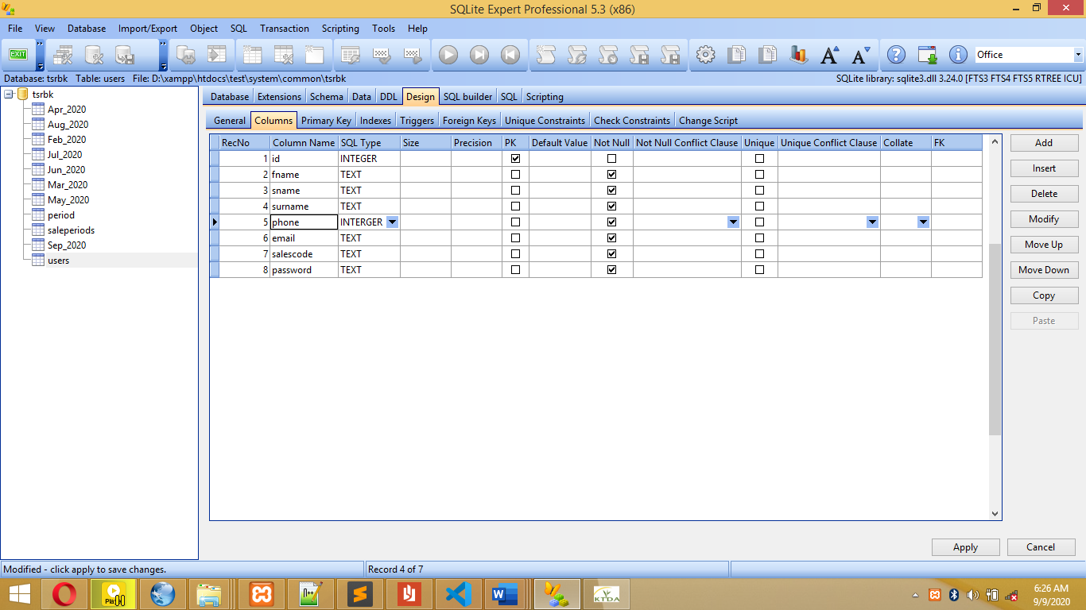

Figure 5.6: 1User information database table.

**sales table**

|  |  |  |
| --- | --- | --- |
| **Field name** | **Type** | **Description** |
| Id | Int | Stands for the record entry |
| Day | Text | Marks the day the record was created |
| Salercode | Varchar | Identifies the application users |
| Date_bought | Varchar | Marks the day the product was sold/bought by the company. |
| Time bought | Int | Stores the time the sale was taken/receipt issued |
| Time recorded | Int | Holds automatically the time the user saves the sale in the site |
| Transporter and buyer | Varchar | This holds the recording clerk and the transporter |
| No of bags | Int | Tallies all bags sold |
| Total weight | Float | Denotes the total sale of the day. |

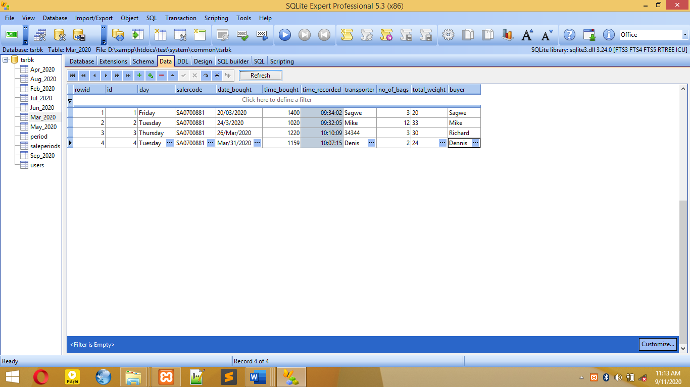

Figure 5.7: Sales database table.

|  |  |  |
| --- | --- | --- |
| **Name** | **type** | **description** |
| Id | Int | Stores the period entry. |
| Month | varchar | Identifies the month of sale |
| Total sales | float | Makes the total of products sold. |

**Period table**

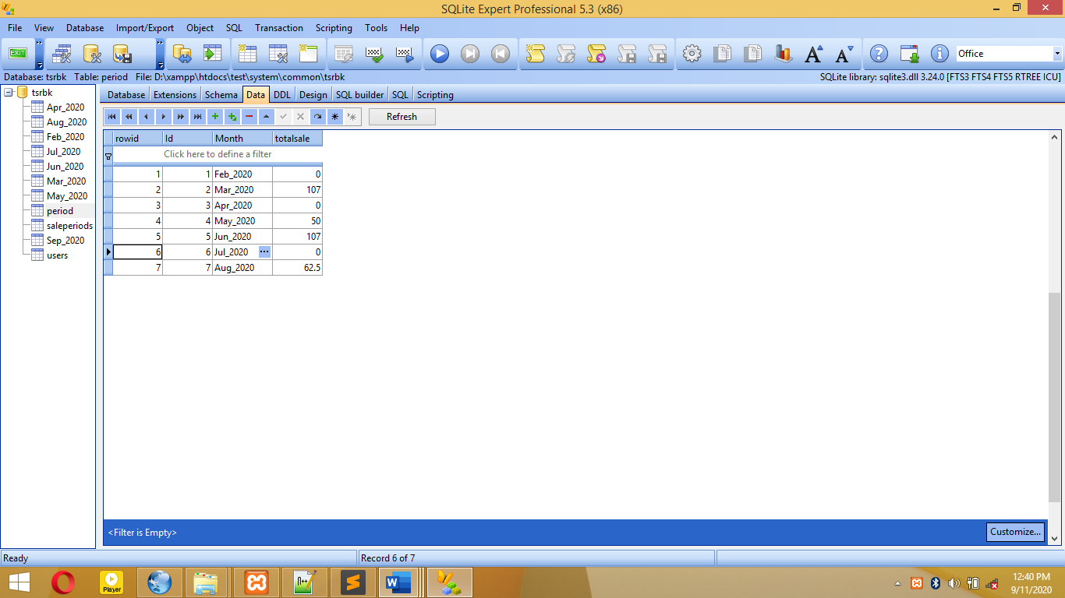

Figure 5.8: Period database table.

**CHAPTER 6: SYSTEM IMPLEMENTATION**

**6.0 Introduction**

This chapter emphasizes the actual system implementation. The system was transformed from user requirement into a workable product. The purpose of system implementation was to make sure that the correct system is delivered to the end user. Besides that, this chapter also emphasizes on how the testing is done to confirm to meets the user requirement.

**6.1 Software Requirements**

**PHP (hypertext preprocessor)**

PHP is a server-side scripting language designed specifically for the web. The goal of the language is to allow web developers to write dynamically. PHP allows interfacing too many different database systems that provides an open database connectivity standard(ODBC) such as. MySQL, Oracle, Microsoft products and others. Other advantages are low cost and availability. PHP is portable across multiple platforms and is created as an open-source

**MySQL (My Structured Query Language)**

MySQL is an open source relational database management system (RDBMS) that uses Structured Query Language (SQL), the most popular language for adding, accessing, and processing data in a database. MySQL is noted mainly for its speed, reliability, and flexibility. It is fast, robust and scalable relational database management system. My SQL is a true multi-user, multi-threaded SQL (structured programming language) database server.

**SQLite** **Expert Professional**

The SQLite Expert Professional is the software that responds to client requests by providing resources, such as XHTML documents. Apache has other powerful features included in a large set of modules, including SQL editor, and many authentication modules.

**CSS**

CSS is the language was used for describing the presentation of system, including colors, layout, and fonts. It allows one to adapt the presentation to different types of devices, such as large screens, small screens, or printers.

**Bootstrap**

Bootstrap is a framework to help in design systems faster and easier. It includes HTML and CSS based design templates for typography, it was used in design of forms, buttons, tables, navigation, modals, and image. It also gives you support for JavaScript plugins.

**6.2 System Implementation**

This describes the tools used to implement the graphical user interface and the database. MySQL was used to create and connect relational tables to the database. HTML was used to develop the GUI. PHP was used to process queries and JavaScript was used to integrate interfaces that lead to the development of the model that meets all the requirements of this system.

**6.3 Systems Testing**

Testing was done after the system was put in place. This was done in two ways namely Unit Testing and integration testing.

**6.4 Test Plan**

The Software Test Plan (STP) is designed to prescribe the scope, approach, resources, and schedule of all testing activities. The plan will identify items to be tested, the features to be tested, the types of testing to be performed, the personnel responsible for testing, the resources and schedule required to complete testing. The purpose of the software test plan is such as:

* To achieve the correct code and ensure all Functional and Design.
* Requirements are implemented as specified in the documentation.
* To provide a procedure for Unit and System Testing.
* To identify the test methods for Unit and System Testing.

**6.4.1 Process of Test Plan**

* + - * Identify the requirements to be tested. All test cases shall be derived using the current design specification.
      * Identify particular test to use to test each module.
      * Identify the expected results for each test.
      * Perform the test.
      * Document the test data, test cases used during the testing process.

The following explain the ways in which testing is done.

* + 1. **Unit Testing**

Unit testing was carried out on individual modules of the system to ensure that they are fully functional units. This was done by examining each unit, for example the Admission page. It was checked to ensure that it functions as required and that it adds patient’s data and other details and also ensured that this data is sent to the database. The success of each individual unit gave the go ahead to carryout integration testing. All identified errors were dealt with.

* + 1. **Integration Testing**

Integration testing was carried out after different modules had been put together to make a complete system. Integration was aimed at ensuring that modules are compatible and they can be integrated to form a complete working system. For example, the system was tested to ensure that the number of bags sold, most of them are not overweight or underweight, mentioning a few of the inappropriate mistakes.

* + 1. **System Validation**

As one of the specific objectives of this study, validation of the system was very important.

Validation of the system was done by comparing it to the by set objectives of the system. Most of their answers matched with what the system can do. JavaScript was used to validate user input and the respective input. For example, the system does not accept blank field; the system also discriminates between numerical and non-numerical characters.

**6.5 Presentation of results**

The presentation of the results of P.O.S was analyzed in terms of the interfaces of the system and output from the backend of the system. This includes activities of the users. The design goals were meet successful in terms of interfaces and functionalities as prior discussed.

**6.7 Proposed Change-Over Techniques**

As technologies change, there is need to change over the computer information systems. Upgrading these systems helps optimize the efficiency and remain competitive. Common changeover areas include security systems, database systems, accounting systems and managerial information systems. Deciding which changeover technique will work best for a particular organization depends on the type of changeover and degree of risk for the organization. As for LHIEMS system the proposed change-over technique is pilot and parallel Change-Over techniques.

**Parallel Changeover**

In a parallel changeover, the new system runs simultaneously with the old for a given period of time. Of all the techniques, this tends to be the most popular, mainly because it carries the lowest risk. If something goes wrong at any point, the entire system can be reverted back to its original state.

**Pilot Changeover**

With a pilot changeover, the new system is tried out at a test site before launching it to the intended organization. For example, the hospital can implement the system for a week test.

This branch is referred to as the pilot, or beta, site for the program. Since parallel

changeovers tend to be expensive, using the pilot changeover technique allows hospitals to run the new system next to their old but on a much smaller scale

# CHAPTER SEVEN: LIMITATIONS, CONCLUSIONS AND RECOMMENDATION

## **INTRODUCTION**

In this chapter I will give a brief summary about the dissertation, and highlight the importance of the project as well as what will be achieved. I will also include a discussion of crucial points related to the problems to be solved in the project and present future work and ideas to improve the system that will be developed.

## **LIMITATION**

My main objective of developing this system is to reduce the paperwork involved in the green tea selling by farmers that are provided with small receipts that are not durable and fade easily. For these reasons, the farmers are not able to keep the receipts for over six months for reference that is usually essential in the tea production financial year as by the terms of the processing companies.

The limitation of this system is that it needs the receipt and it does not accept weights that are less than 3.5 to avoid recording of many underweight that in return bring losses in terms of tare weight that benefit the company in return.

Also, in the system, user registration is mandatory. Meaning all unregistered user’s need to be registered either by the administrator or self registration is allowed but all the mistakes made during registration cannot be corrected by the administrator. The same problem applies in the new record addition. All the errors committed are only corrected by the database admin.

Another drawback of the system in the chart page , the main template is used since the system only supports annual summarization. And the system needs frequent refreshing to update the total weights. This are the major drawbacks of the system that need to be eliminated in the system maintenance.

## **CONCLUSION**

In conclusion, the project proposal is important in computer science degree program since it gives the student the purposive skills in conducting computer science project research. Among the skills gained are software documentation, design, development and implementation that are theoretically taught in class. The literature review has been as well been focused as a real need for every researcher. This has led to realization or the view of problems directly from the floor.

This course has also help me to add more programming skills and software reuse as it is implied in software reuse.

## **RECCOMENDATION**

So far, I can highly recommend this system to be adapted in the mentioned field to accelerate the adoption of the technological era and prove that technology is dependable. The system is able to be supported by a variety of devices. Therefore this system is recomeendable.

## **References**

Bassil, Y. (2012). A simulation model for waterfall software development lifecycle . *Internationa Journal of Engineering and Technology*.

**Appendix**

Code that auto creates database and all tables incase of accidental deletion

Bernard, & HR. (1988). *Research methods in cultural anthropology.* Newbury Park, CA: Sage Publication.

Taylor-Powell E, S. S. (1996). Collecting Evaluation Data:. *Direct Observation.* .

<https://www.google.com/search?client=opera&q=Bookkeeper+2015&sourceid=opera&ie=UTF-8&oe=UTF-8>

<https://www.google.com/search?client=opera&q=Intuit+QuickBooks+Online&sourceid=opera&ie=UTF-8&oe=UTF-8>

<https://www.waveapps.com>

<https://farmtable.com.au/accelerate-software/conservis/>